Exp: Experiment 1 - Addition of 2 8-bit numbers
Aaron Gomes
UID: 2025300073

Aim:
Addition of 2 8-bit numbers in 8086 in dosbox

Code:
.MODEL SMALL
.STACK 100H

.DATA
NUM1 DB 25H
NUM2 DB 15H
SUM DB ?

.CODE
MAIN PROC
MOV AX, @DATA
MOV DS, AX

MOV AL, NUM1
ADD AL, NUM2
MOV SUM, AL

MOV AH, 4CH
INT 21H

MAIN ENDP
END MAIN

OUTPUT:
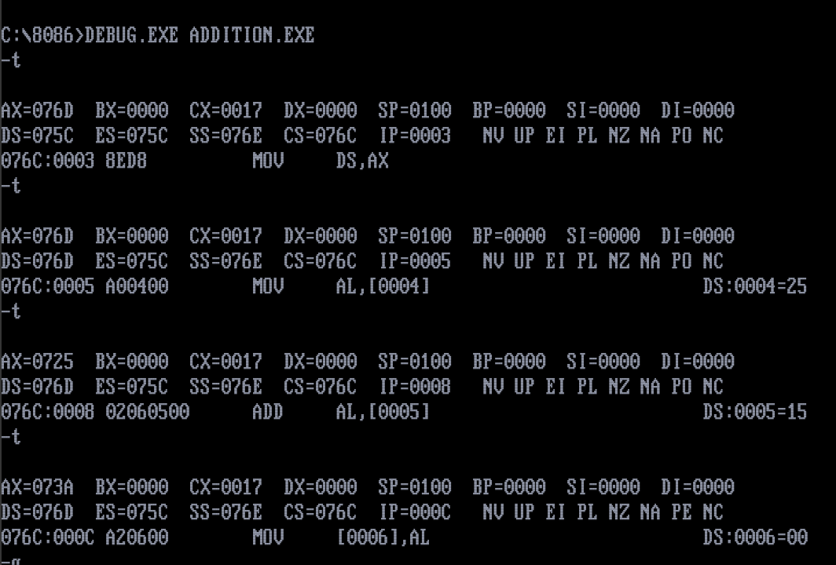

Conclusion:
2 8-bit numbers were added and output obtained in the AL register after using the debug command in dosbox.

